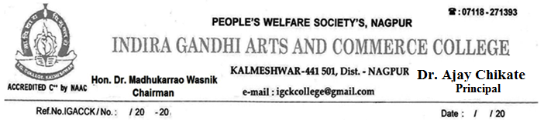

FACULTY FEEDBACK FOR CURRICULUM AND INSTITUTION

Name:______________
_____________________________________________________
Rate the Institute on Scale 1 to 4 on the basis of following aspects: Excellent:4 Good:3 Satisfactory:2 Poor:1
Sr.  No. | Questions | Rating
1 | The books/journals etc. prescribed / listed as reference materials are relevant, updated and cover the entire syllabus
2 | The courses / syllabi of the subjects taught by me increased my interest, knowledge and perspective in the subject area
3 | The curriculum has given me full freedom to adopt new techniques / strategies of teaching such as group discussions, seminar presentations and learners' participation
4 | I have the freedom to adopt new techniques / strategies of testing and assessment of students
5 | ICT facilities in the college are adequate and satisfactory
6 | The classrooms and labs are clean and well maintained
7 | Faculty Room is adequate and available in the Institute
8 | Toilets / Washrooms are clean and properly maintained
9 | Are you satisfied with welfare measures offered by Institute?
10 | The administration is teacher friendly.

Any other Suggestion:
_ _
_ _

Date: Signature ofFaculty

