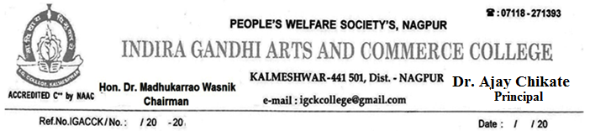

EMPLOYER/ RECRUITER FEEDBACK FORM
fu;ksDR;kps vfHkizk; i=d

Employer Name deZpk&;kps uko
Designation inuke@gqÌk
Industry Name laLFksps@ m|ksxkps uko
Mobile No. Hkze.k/ouh dz-
Email-id bZ&esy vk;Mh
Rate the Institute on Scale 1 to 4 on the basis of following aspects:
[kkyhy eqÌ;kaP;k vk/kkjs 01 rs 04 ;k Lrjkuqlkj xq.k nsÅu vfHkizk; i=d Hk:u ns.;kr ;kos%

Excellent: 4 Good: 3 Satisfactory: 2 Poor: 1
mRRke % 4 pkaxyk % 3 lek/kkudkjd % 2 fu”d`”B % 1

Sr. No. | Questions | Rating
1 | Ability of the employee to apply the concepts of social work  Lkkekftd dk;kZizrh deZpk&;kph vkoM@ {kerk-
2 | Ability of the employee to identify, formulate, interpret, analyze and solve problems jkstP;k dk;kZrhy leL;k vksG[kwu] letwu ?ksÅu] lw=c/ni.ks fo’ysf”kr d:u lksMfo.;kph deZpk&;kph {kerk-
3 | Ability of the employee to understand and take in to considerations economic, environmental, social, political, ethical and health and safety constraints in the work deZpk&;kph vkfFkZd] Ik;kZoj.kh;] lkekftd] jktdh;] uSfrd] vkjksX;n`”;k vkf.k lqjf{krrk ;kaP;k e;kZnk letwu ?ks.;kph {kerk-
4 | Ability of the employee to communicate  deZpk&;kph laokn lk/k.;kph {kerk-
5 | Ability the employee to take initiative and demonstrate leadership  dEkZpk&;kph iq<kdkj ?ksÅu usr`Ro dj.;kph {kerk
6 | Ability the employee to work in a team  deZpk&;kph la?kVhri.ks o xVke/;s dke dj.;kph {kerk
7 | Ability of the employee to understand professional and ethical responsibilities  l|kifjfLFkrh jkstxkjkdfjrk l{ke vkgs dk\ mRiknu xjtsoj vk/kkjhr o cktkjkrhy rRokl vuql:u vkgs dk\
8 | Syllabus is suitable for Employability and is need based and as per current trends in market  deZpk&;kpk O;kolkf;d o uSfrd tckcnkjh letwu ?ks.;kph {kerk-
9 | Ability of the employee to get inclined towards lifelong learning  deZpk&;kaph uO;k f’k{k.kkdMs vkdf”kZr gks.;kpk dy\
10 | Syllabus takes care of knowledge and skills of the students and has good balance between theory and application  deZpkjh vkf.k dkS’kY; ;krhy lerksy] R;krhy Kku o uouohu iz;ksx ;kauk izfrlkn ns.;kph {kerk-

Any other Suggestion brj lwpuk:
____________________________________________________________________________________
____________________________________________________________________________________

Date fnukad: Signature lgh

