Contents. 2023-2024
Programs Taken in the year 2023-2024
Si.no. | Date | Name of Program | Conducting organisation / Chief guest
1 | 13.12.23 | Sickle cell Guidance and Examination | Shri. Niket Pokle, Lab Scientist
2 | 03.01.24 | Women’s Empowerment | Mr. Harshal Hattle,
3 | 13.01.24 | Women’s Empowerment | Geeta Dalvi, Advocate. Son… .
4 | 09.03.24 | Women’s International Day | Prof. H. Bagde

Under the “Women’s Cell” various programmes were taken.
To recognize women’s contributions, achievements and experiences ---
- To spread awareness regarding nutritious diet, HIV and Sickle cell , a workshop on Sickle Cell Awareness and examination of Sickle Cell and HIV was held on 13.12.23, with the help of the Gramin Rughnalaya, Kalmeshwar. About 200 students were tested for sickle cell and HIV. From these 4 turned out to suffering from sickle cell. They were advised to visit the Gramin Rughnalaya of Kalmeshwar , for further treatment.

- Next, Savitribai Phule Jayanti was celebrated on 03.01.24. The chief guest of which were Geeta Dalvi, Women’s Cell , Kalmeshwar Police Station, Son Madam, Samupadeshan Kendra , and Kalambe Madam, from NGO, Yashwant Balaji Bahuudeshiya Samajik Santha,Kalmeshwar, were present. Advocate Son Madam asked the students to empower themselves with knowledge and to build up their confidence. She also guided them on various laws regarding domestic violence.

3) The students were made aware of various opportunities available in the field of business. They could begin their own household business in various ways. Industrialalist Mr. Harshal Hattle, guided the students on how to begin small business from home, how to get the raw material, how to sell it and how to spread their business , on the occasion of women’s day- 13.01.24
4) Women’s International Day was celebrated on 09.03.25. The Chief Guest was Prof. H. Bagde . He guided the students by giving various examples of the great female workers in various fields. He said that if they wished to change their situation to a better one, it was necessary to take proper education.

महिला सेल अंतर्गत विविध कार्यक्रम घेण्यात आले -----
स्त्रीयांनी केलेल्या योगदानाबद्दल, त्यांच्या उपलब्धी वा त्यांचे अनुभवांतून विद्यार्थ्यांना प्रेरणा मिळावी यासाठी विविध कार्यक्रम घेण्यात आले.
- विद्यार्थ्यांन मधे HIV, सिक्कल सेल वा पोषक आहार बाबत जागरूकता निर्माण करण्यासाठी, १३.१२.२३ ला ग्रामीण रुग्णालया, कळमेश्वर अंतर्गत कार्यक्रम घेण्यात आला. जवळपास दोनशे विद्यार्थी ह्या कार्यक्रमाला हजर होते. त्यांची तपासणी केली असता ४ जणांना सिक्वल सेल असल्याचे दिसून आले. त्यांना पुढिल मोफत उपचारासाठी रूग्णांलयात येण्यास सांगितले.
२) सावित्रीबाई फुले जयंती साजरी करण्यात आली ३.०१.२४ ला. ह्यांचे मुख्य पाहुणे गिळता दळव, एन जी ओ, वुमेन्स सेल, कळमेश्वर पोलिस स्टेशन; आडवोकेट सोनं मॅडम, समुपदेशन केंद्र आणि कलंबे मॅडम, यशवंत बहुउद्देशीय सामाजिक संस्था , कळमेश्वर, होत्या. ह्यांनी शिक्षण हे सामाजिक दुष्प्रवृत्ती नष्ट करण्यासाठी सर्वात मोठे शस्त्र आहे , असे श्रोत्यांना सांगितल. व सर्व विद्यार्थ्यांना योग्य शिक्षण घेऊन आपला आत्मविश्वास वाढविण्यास सांगितले.
३) उद्योग क्षेत्रात उपलब्ध असलेल्या विविध संधी ह्यावर उद्योजक हर्शल हट्टा, ह्यांनी विद्यार्थ्यांना मार्गदर्शन केले , वूमेंस डे १३.०१.२४ ह्या कार्यक्रमा अंतर्गत.
व्यवसाय कसा सुरु करावा, त्यासाठी कच्चा माल कोठून आणावा, तय्यार माल कसा विकावा ह्यावर माहिती देण्यात आली.

४) महिला अंतर्राष्ट्रीय दिवस ०९.०३.२५ ला मिळवण्यात आला.
ह्यांचे मुख्य पाहुणे डॉ. बागडे होते. त्यांनी स्त्रियांनी विविध क्षेत्रात केलेले योगदान ह्यावर माहिती दिली.

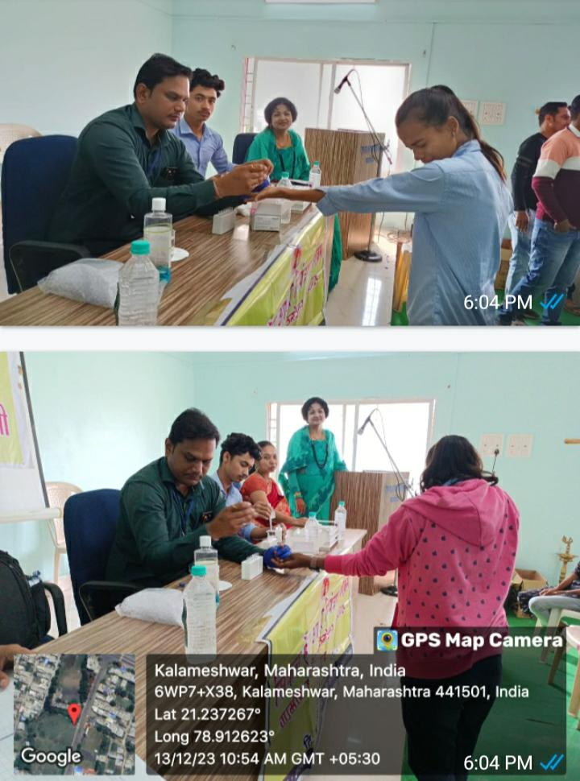
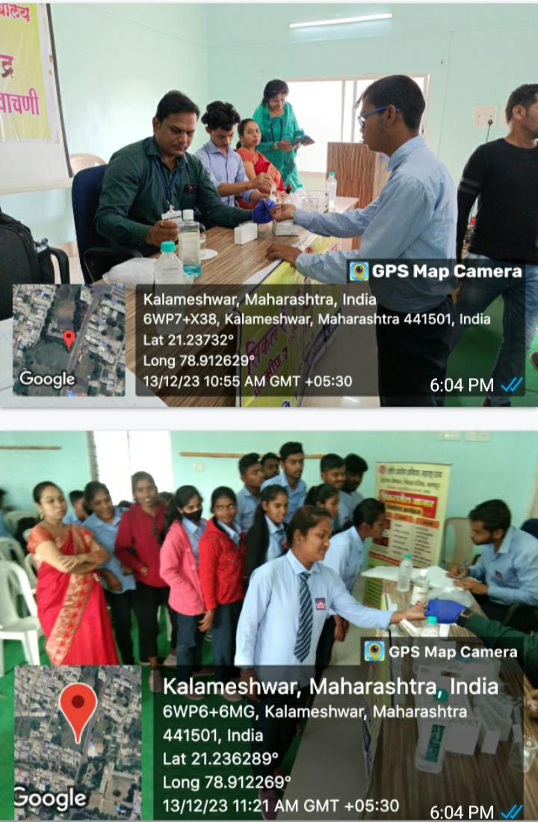
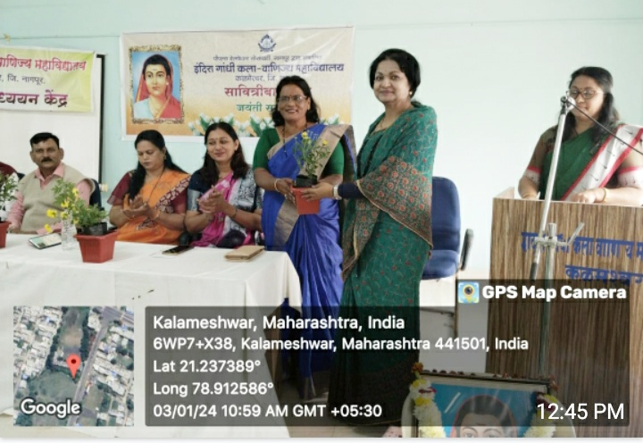

Women’s Empowerment” ---03.01.24

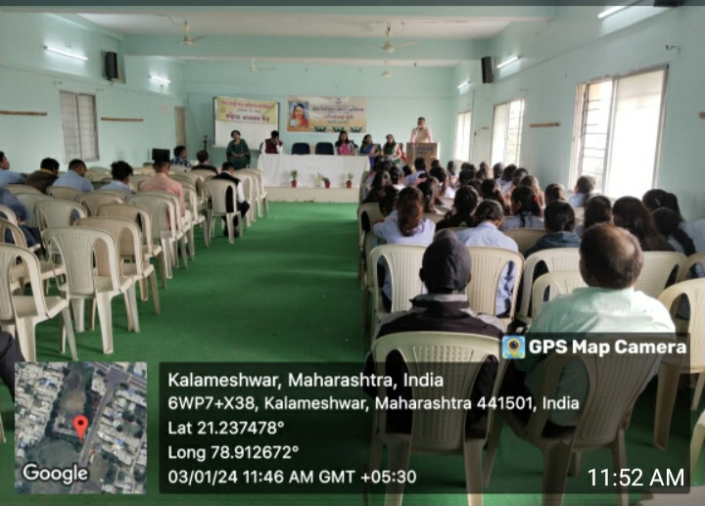
Chief Guest – NGO Geeta Dalvi, Advocate Son Madam & Mrs Shewalkar, Mahila Adhikari.

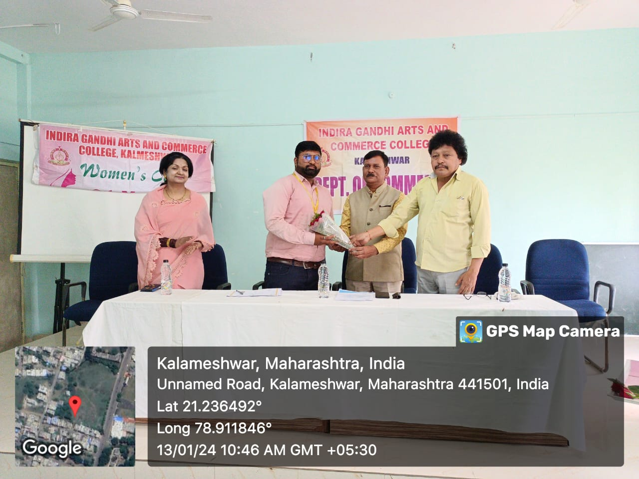
Skill development 13.01.24/ Chief Guest – Mr. Harshal Hattle
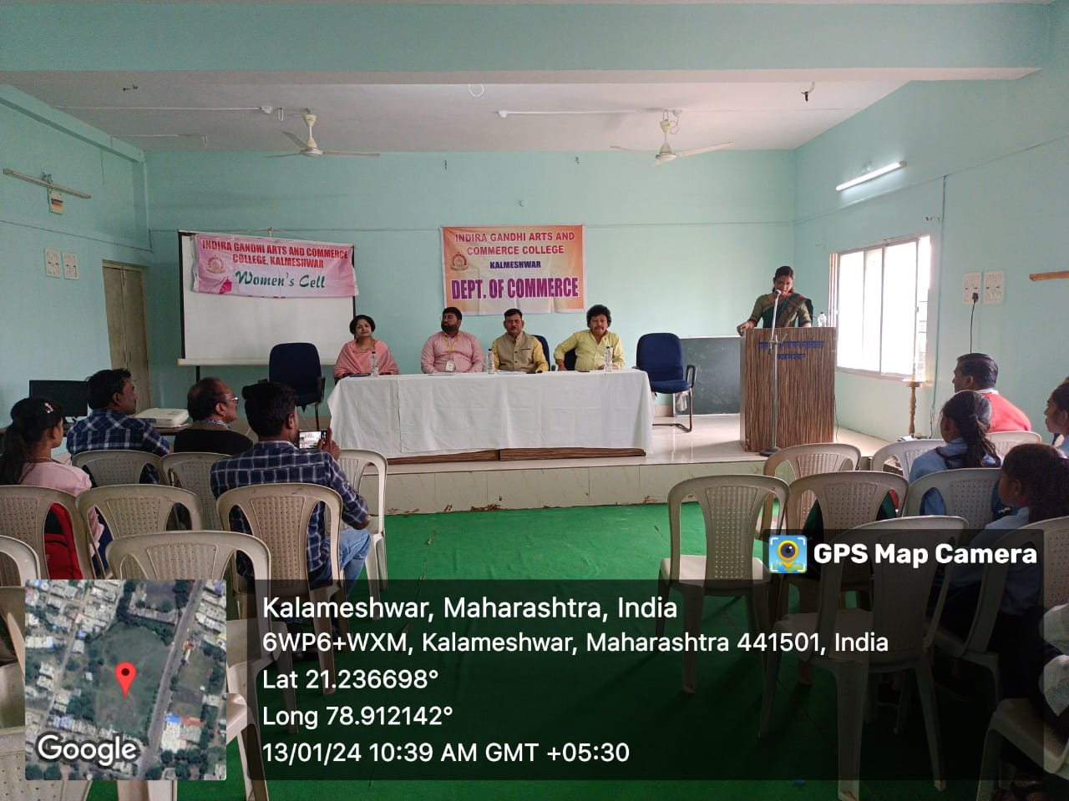

Women’s Cell celebrated 09 March 2024 as International Women’s Day.
It was chaired by Prof. H. Bagde and attended by various teachers and students of the college. B.A.Part II student – Daya Kelwade presented an inspirational speech on Arunima Sinha. She related how she her courage and determination made her the first amputee women to scale Mt. Everest.
On this occasion Dr. Manjusha Dhoble informed the students on the importance of the day and how it came to be observed by all the women of the world as international Women’s Day. She explained how about 15000 textile women workers marched the streets of NewYork for their rights as human, for equal pay as that of men and to stop their harassment at various stages like the long working hours.
The chief guest Dr. Bagde sir presented his poem on woman in his speech.
Thus about 34 students attended the program.
