Women’s cell activity 2025
Lantern making and other paper decoration items

Academic year | 2025
Type of Activity | Lantern making and other paper decoration items
Date of Activity | 15.09.25
Organized by | Women’s Cell
Students present | About 30
Name of chief guest | Mr. Daljit Kaur
Objective of the program | To empower women with art and make them self employed
The program | The chief guest start the students how to make various decorative items from paper. He taught the students to make various flowers and Diwali lanterns to decorate their homes. He told them that day could sell these lanterns and become self employed.

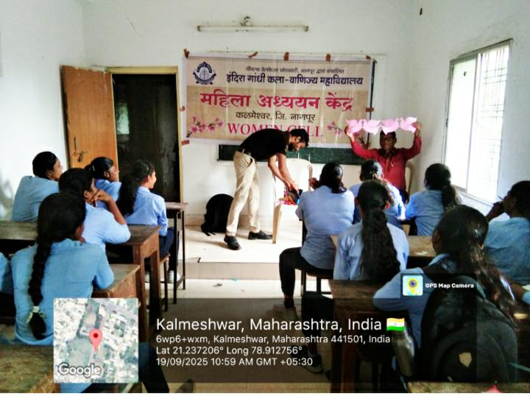
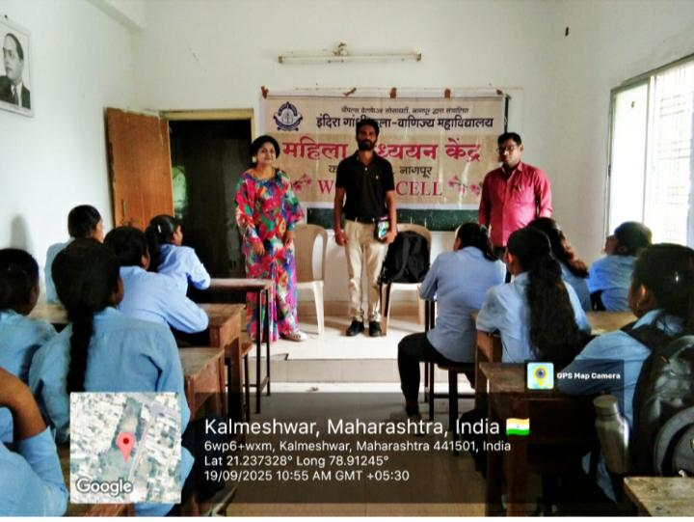

Women’s cell activity 2025
Nutritious diet and students examination
Academic year | 2025
Type of Activity | Nutritious diet and students examination
Date of Activity | 15.09.25
Organized by | Women’s Cell
Number of students present | About 45
Name of chief guest | Dr. Ramteke, Dr. Meshram, Jitendra Bhoyar, Manju Kolhe
Objective of the program. | To examine the students health and guide them about nutrition.
The program | The students where guided on nutritious health and examined for any deficiency's of sickle cell and HIV.

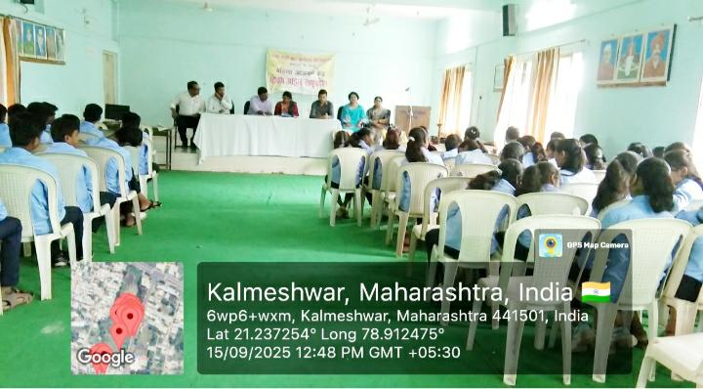
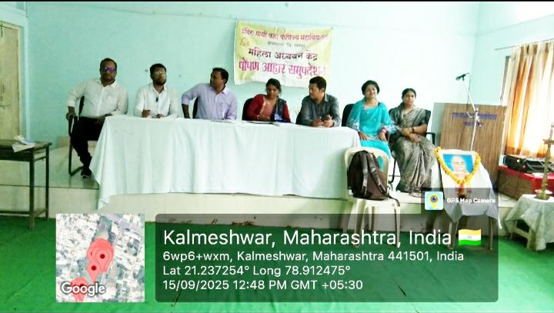

Women’s cell activity 2025
Problems of Sexual Abuse and Domestic Violence
Academic year | 2025
Type of Activity | Problems of Sexual Abuse and Domestic Violence
Date of Activity | 08.10.25
Organized by | Women’s Cell
Number of students present | 105
Name of chief guest | Geeta Dalvi Madam, NGO, Yashwant Balaji Bahuddeshiya Samajik Sanstha, Kalmeshwar
Objective of the program. | To empower women with knowledge of sexual abuse and domestic violence
The program | The chief guest guided the students regarding bad touch and good touch. She told them about the domestic violence act and how to prevent violence and how to face it amicably.

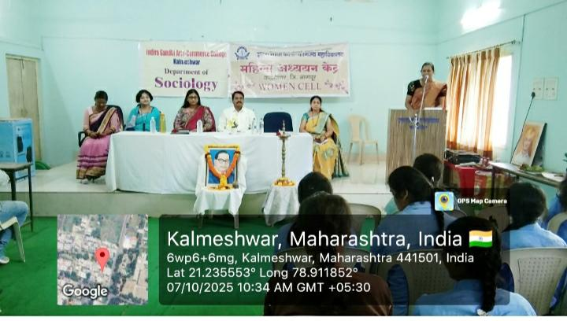

Women’s cell activity 2025
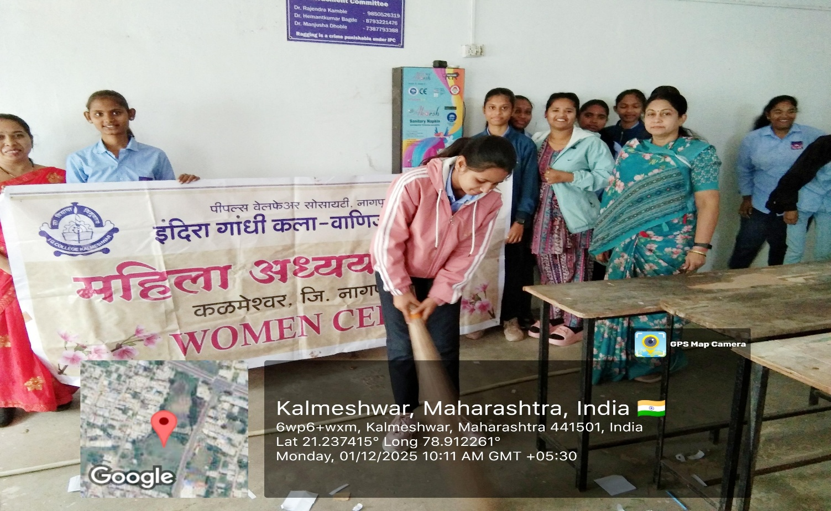
World Toilet Day – Safely Manage Sanitation
Academic year | 2025
Type of Activity | World Toilet Day
Date of Activity | 01.12.25
Organized by | Women’s Cell
Number of students present | About 20-25
Name of chief guest | Sukanya Bobde Madam
Objective of the program. | To spread awareness of hygiene and cleanliness
The program | The students cleaned the toilets with water pipes. They were taught about the use of dustbins, vending machine, and disposal of used sanitary napkins.

Women’s cell activity 2025
Mental health awareness workshop
Academic year | 2025
Type of Activity | Mental Health Awareness
Date of Activity | 04.12.25
Organized by | Women’s Cell
Number of students present | About 120
Name of chief guest | Arti Lokhande, Poonam Khunkar, Prajakta Girighuse
Objective of the program. | To spread awareness of mental health and its relevance
The program | The students were told about the abuse of mobile and how it leads to depression, mental depression, giving rise to psychological issues and ending in suicidal attempts
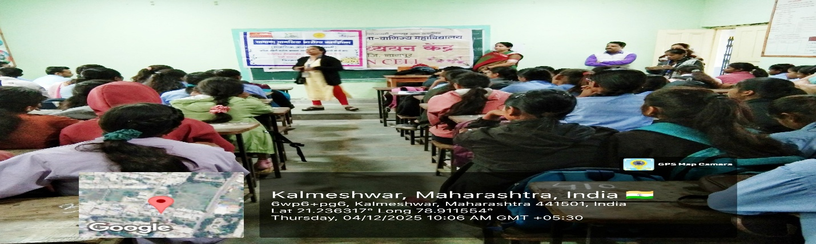

Women’s Cell – Inauguration of Women’s Counselling Cell and celebration of International Women’s Day
Academic year | 2026
Type of Activity | Celebration of International Women’s Day and the Inauguration of Women’s Counselling Cell
Date of Activity | 09.03.26
Organized by | Women’s Cell
Number of students present | About 35
Name of chief guest | Mr. Arun Nagarjoge (Deputy PI), Police Station, Kalmeshwar; Mrs. Geeta Dalvi ( Cunsellor, Police Station, Kalmeshwar); Mrs.Gayatri Karbhari, Area Manager, Agragami Mahila Nagrik Co-operative Bank, Nagpur and Dr. Rajendra Kamble , Offi- Principal of I. G. College, Kalmeshwar
Objective of the program. | To celebrate the achievements of women and inspire forthcoming women.
The program | On this occasion a counselling cell was inaugurated and the chief guests Geeta Dalvi Madam and Gayatri Karbhari were gifted with parcels. All other guests and ladies were presented with roses.
